Worst-Fit

Pros:

* Makes use of all resources from large servers
  + Increases utilization of larger servers

Cons:

* Can cost more
* Can take longer due to not using multiple servers (if only 1 large server is used)

Best-Fit

Pros:

* Makes use of the resources available and chooses the server with the smallest amount of cores that is still equal to or more than that of which is required
* Improves utilization time and possibly turnaround time

Cons:

* As resource utilization is increased, it may affect cost

First-Fit

Pros:

* Quickly selects a server that can immediately run the job

Cons:

* Can increase cost
* Lowers resource utilization

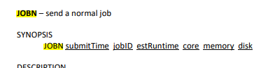

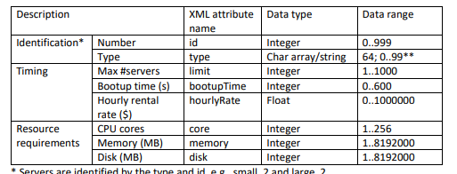

SCHD: jobID serverName serverID